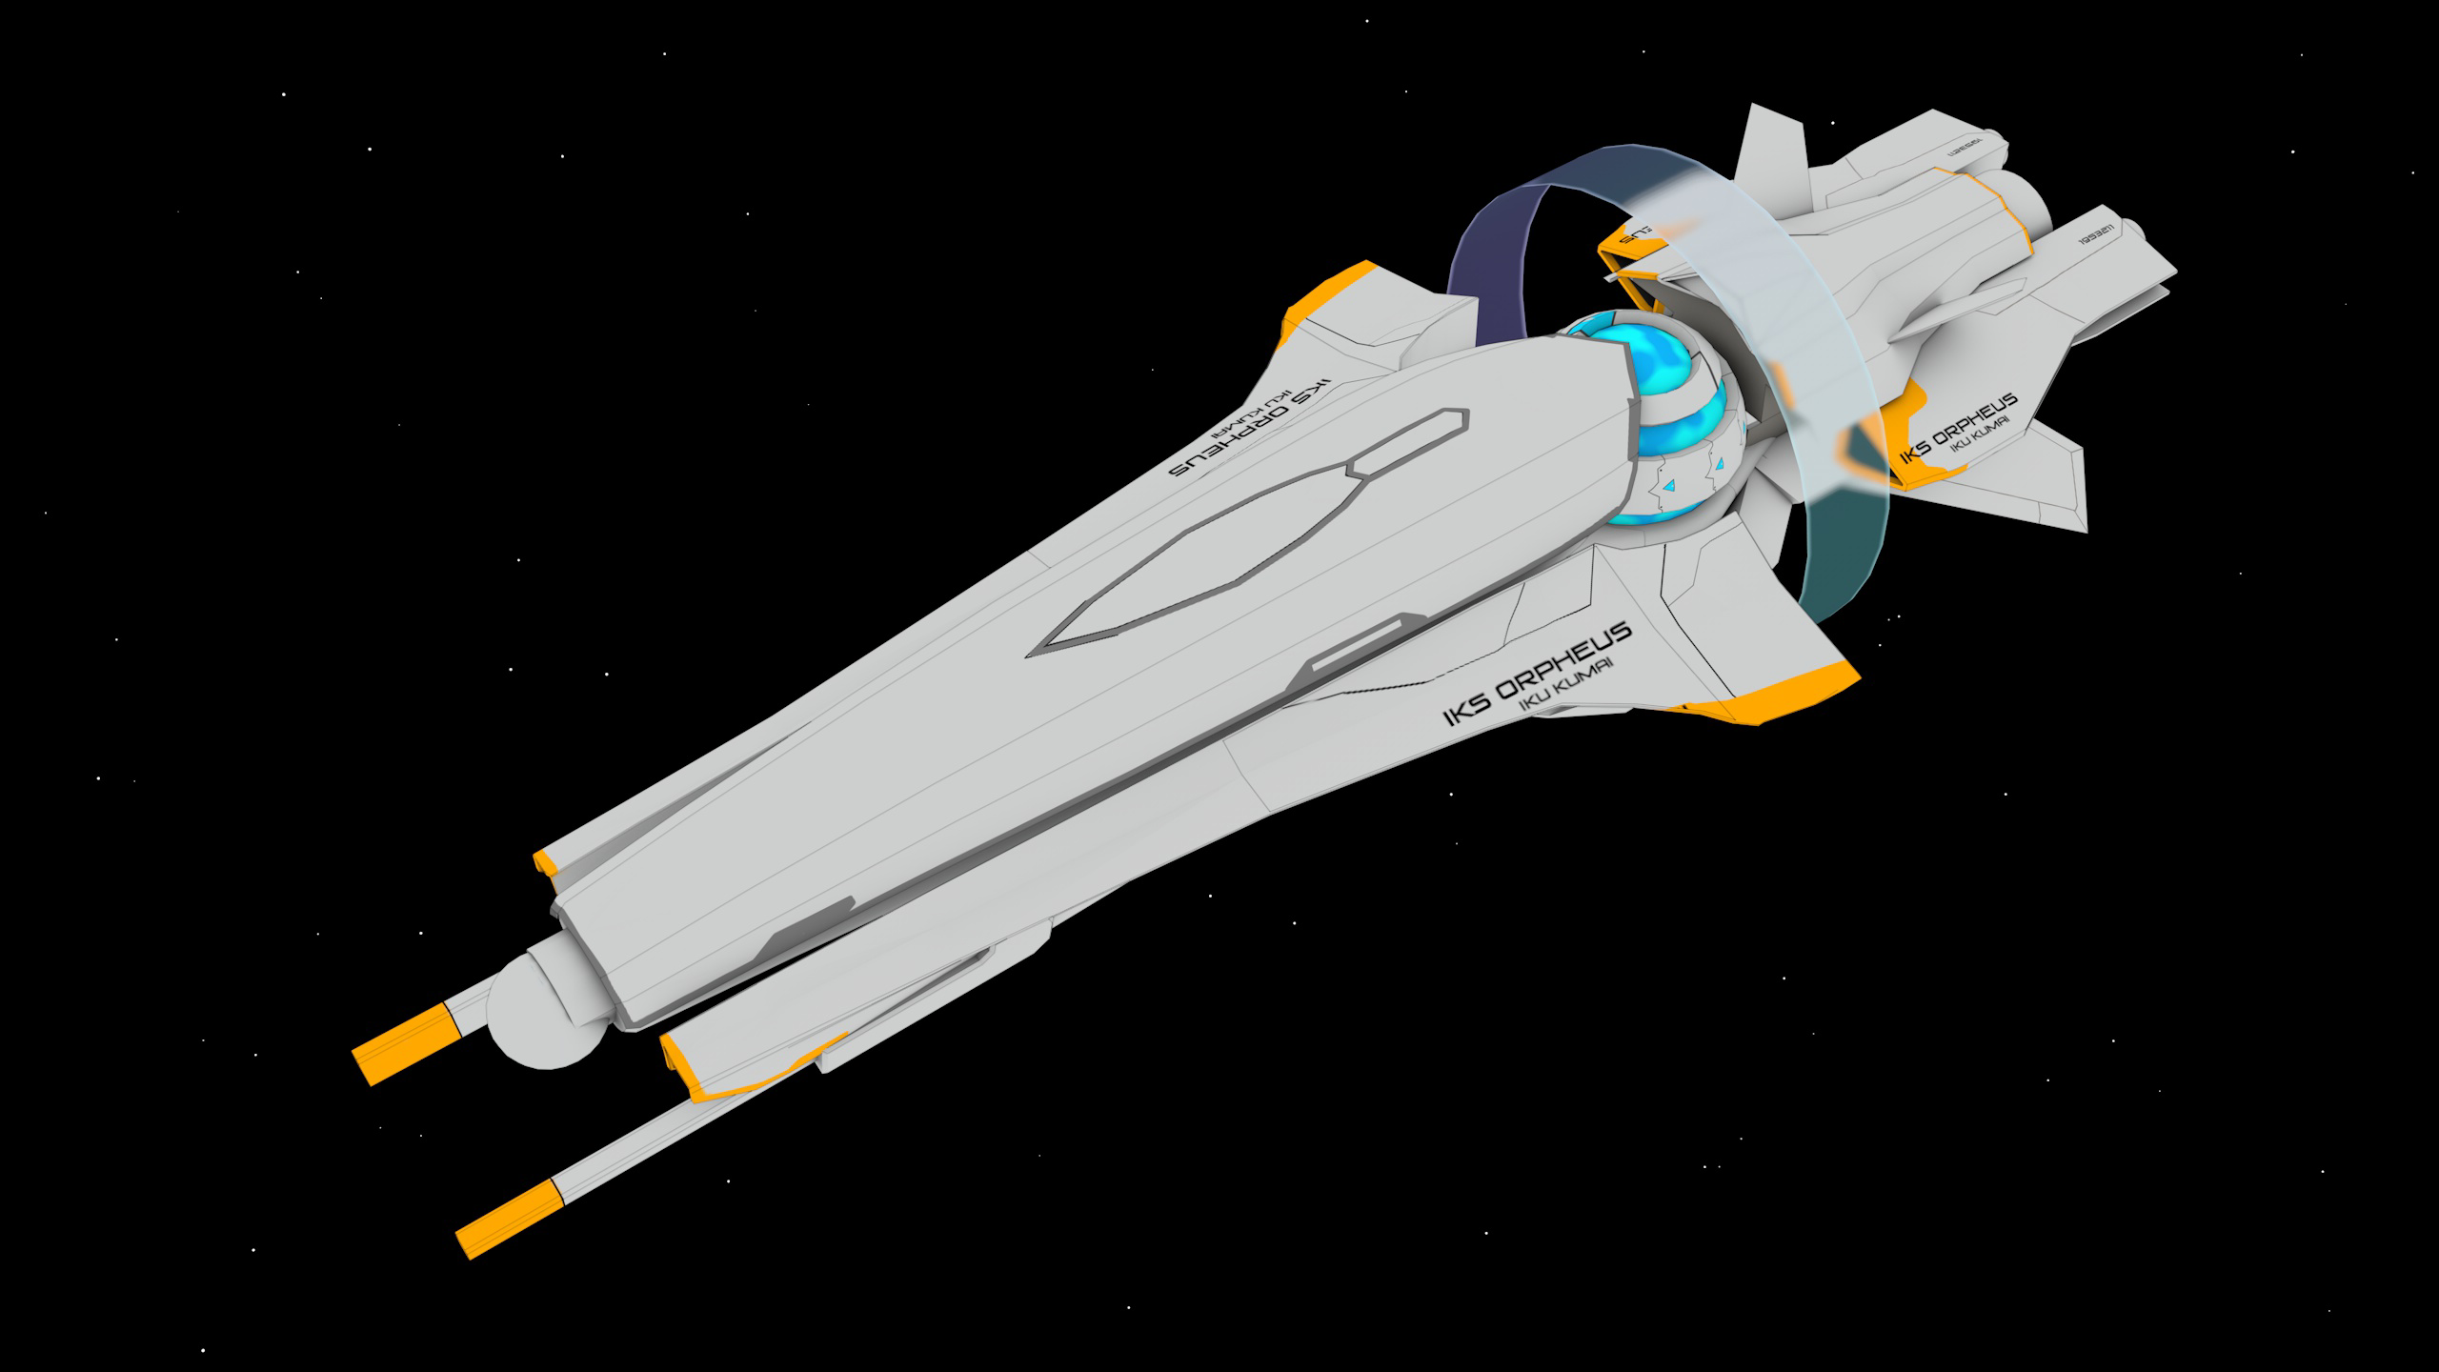

It is in the nature of man to fear what he doesn’t understand, which is why Erik, Head of Operations on the IKS Orpheus, stayed as far as possible from their Projected Singularity. On a good day, the singularity was about as big around as a thumb, or a .50 caliber bullet if one was morbid, merrily piping energy from whatever dimension it opened to. On a bad day, like today, it was opened for maintenance. Erik sipped his green tea, eyes narrowed, from an observation window as the small team’s physicist, Hans Schmidt, stuck his wrench through the meter-wide portal in the middle of its containment apparatus. The man was absolutely nuts. But the wrench came back through with minimal damage. Hans nodded, as if this had been some kind of test that the wrench had passed, pressed a few buttons, and the blue-black void shrank back down to its thumb-sized circle of dread.

A singularity of course had infinite mass, but some smart person had circumvented that by projecting it onto a plane. In any sane universe, this is the equivalent of dividing infinity by zero, but as that would doubtless cause some errors in the fabric of the universe, reality seemed to settle for just making the damned thing's mass a few kilograms.

“All done here, Erik.” Hans said, waving to Erik. Erik waved acknowledgement, trying not to let his trepidation escape his face as he made his way to the front of the Orpheus, where the sensor officer and the biologist, a Virginia Chad and a Pollette Ramirez, respectively, were examining the sensor data.

“Anything interesting?” Erik asked. He, of course, could have consulted the ship’s central database with just a thought, where they’d doubtlessly been posting their nearly minute-by-minute reports, but he preferred, for cohesion purposes, to ask his crewmates directly.

“Hey chief.” Ramirez grinned. When she saw Virginia acknowledge Erik and look back at her sensor readouts, she grabbed Erik’s ass politely. Her eyes asked him the unspoken question, and he winked back. He trusted she understood his happy acquiescence to her request, and the two turned back to Virginia and tried to keep a straight face.

“Can y’all turn the horny down, please? It’s very annoying.” Virginia grumbled without glancing away from her computer.

“Sensors, Virginia.” Pollette said. “As I was saying, Erik. This is probably the most boring type AB planet we’ve ever seen.”

“What are we talking?” Erik asked.

“Oh, the standard stuff.” Virginia said. “I mean, forests, small animals, a few big ones, algae and plankton in the oceans, you know how it is.”

“Hey Erik, check this out.” Pollette said, pointing to some wavy lines on her screen.

“What’s this?”

“Well, the majority of the landmass is on one hemisphere, so as the day progresses, that land gets an amount of sunlight that looks like a sinusoidal curve.” She pointed to the charts. The Y was labeled with “percentage of landmass in sunlight” and the X was labeled “Time, days”. The plot indeed followed a rough sine curve, maximizing when the whole planet was in sunlight.

Erik, a mechanical engineer by training, immediately caught on.

“Fair.” He said. “Where are you going with this?”

“Watch.” She said. She brought up another graph. This was the oxygen percentage in the air. This varied from 22 to 25%, so not a dramatic change, but you could see that it, too, varied in a sinusoidal pattern that matched the period of the landmass sunlight curve.

“It breathes, Erik!” She said. “At night, the plankton die off and decay, consuming oxygen, and in the morning, the plants on land bring it back! It’s beautiful!”

“Yuh, just like Earth and like… every planet we’ve been to.” Virginia sighed. “This is a dud, boss. As soon as the singularity drive is back, let’s get out of here.”

The planet, called 293 Van Ness (the latest trend was to name planets after famous streets, and Champs Elysees and Lombard were taken), was the eighth of their twenty-planet catalog that an autonomous probe had rated as earth-like. The probe could detect no radio transmissions, of course, or it would have screamed a lot louder, but that didn’t mean that there were no intelligent pre-industrial societies on the planet. The probe wasn’t smart enough. For that, they needed humans to have eyes on. And if such an inhabited planet was found, the reward for the discovering company would be legendary, so scout teams like Erik’s were fairly common.

And this planet was also fairly common, to be frank. There was nothing special about earth-likes. About one in a hundred star systems had them, that could be carbon copies of this planet. Different continents, of course, but plate tectonics, water oceans, and life. About one in twenty earth-likes (AB) had animals and tree-like plants. They were investigating the ones most likely to have civilizations. And Van Ness was no such planet. It was missing any kinds of unnatural CO2, no straight lines from roads and runways, nothing even resembling hunter-gatherer primate-equivalents.

“Another dud.” Christina Mao, the ship’s “Captain” and navigation officer, grunted from her control room. “Well, nothing for it. Hans says the drive is up, so let’s take a two hour break and charge her up.”

Erik awoke to the sound of Christina’s voice on the intercom announcing that their departure from the planet was imminent and that, since it was 7:00 PM ship time by now, they’d be sleeping when they arrived at the next planet.

“You want to be awake when we jump?” Pollette said from his room’s bathroom. She was re-applying her makeup after it had been smudged. Erik cracked his eyes open a little wider to take an eyeful of her standing next to the mirror wearing nothing but one of his T-Shirts.

“You’re not going to go out of the room wearing that, right?” He croaked.

“I’ll put on some panties.” She smiled a mischievous smile. He managed to put a pair of track pants on and was pulling his own shirt over his head when there was a strange rumbling in the floor.

“Huh, you feel that?” Pollette asked, pausing her eyeliner application.

“Yeah, that’s not a good sign - ” Erik started, when the whole world turned upside-down and he was on the ceiling of the room. He felt something cracking and the world went black.